**Session 15: Assignment 1**

**Problem Statement 1:**

You survey households in your area to find the average rent they are paying. Find the

Standard deviation from the following data:

$1550, $1700, $900, $850, $1000, $950.

Code:

import pandas as pd

rent = [1550,1700,900,850,1000,950]

df = pd.DataFrame(rent)

df.mean()

df.iloc[:,0].mean()

df.iloc[:,0].std()

Output:

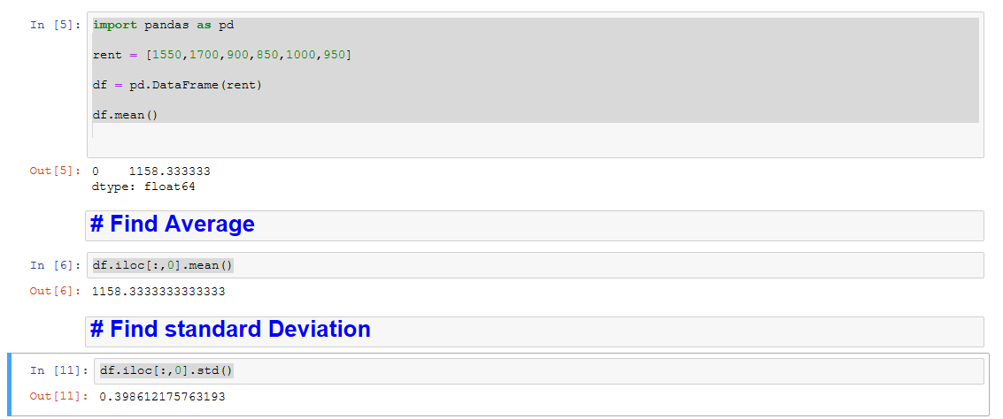

**Problem Statement 2:**

Find the variance for the following set of data representing trees in California (heights in

feet):

3, 21, 98, 203, 17, 9

Code:

import pandas as pd

height = [3,21,98,203,17,9]

df = pd.DataFrame(height)

df.var()

df.iloc[:,0].var()

Output:

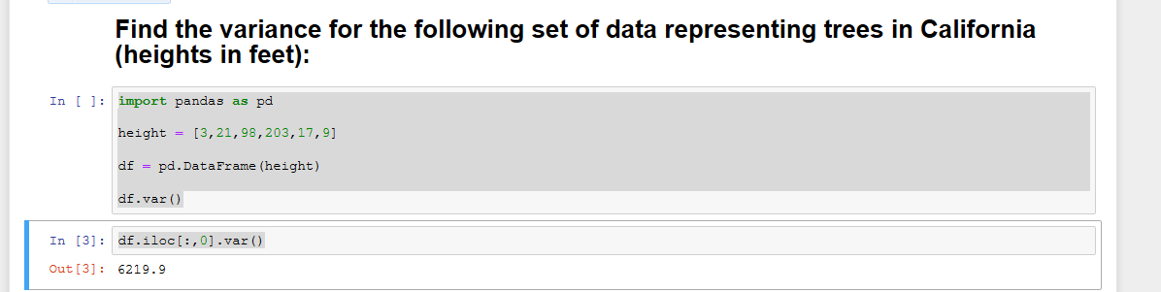

**Problem Statement 3:**

In a class on 100 students, 80 students passed in all subjects, 10 failed in one subject, 7

failed in two subjects and 3 failed in three subjects. Find the probability distribution of

the variable for number of subjects a student from the given class has failed in.

Code:

import numpy as np

import pandas as pd

import scipy.stats as stats

list=[0.1,0.03,0.7,0.8]

df = pd.DataFrame(list)

display(df.describe())

# Cummilative Denisty Function

stats.norm(40.75,39.8612).cdf(80)

# Probability Denisity Function

stats.norm(40.75,39.8612).pdf(80)

Output:

